The Plymouth Drake Foundation
Friends Scheme Form
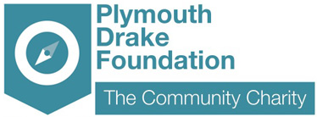
The Community Charity for the Plymouth City Region
We are.....
- A charity that devotes 100% of its time and resources towards helping local people.
- A charity that aims to support and develop wealthy, healthy and lively communities in Plymouth.
- A charity supporting community volunteer groups and small local charities.
- A charity that is helping people of all ages and all abilities in our community.
- A chance for you to give something back to your local community.
- Creating, managing and developing an Endowment Fund solely for the benefit of Plymouth.


Help us to support your local community by becoming a friend of
The Plymouth Drake Foundation.

- Receive regular newsletters
- Receive email updates with the latest news on money we have raised and grants awarded
- Information on events

Join our membership scheme by completing the form and returning it to us at
The Plymouth Drake Foundation, Plymouth Science Park, Derriford, Plymouth PL6 8BX

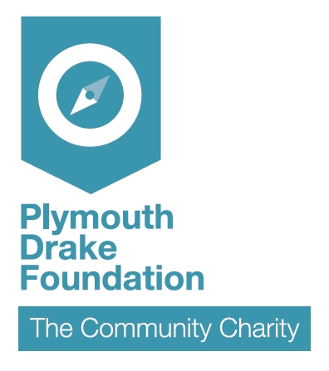
Friends Scheme
APPLICATION FORM
Please return to: Plymouth Drake Foundation, Tamar Science Park, Derriford, Plymouth PL6 8BX

E Mail: plymouthdrakefoundation@gmail.co.uk  Web: www.plymouthdrakefoundation.co.uk Tel: 01752 764455
YOUR DETAILS

Name:

Address:

Postcode: Telephone:

Date: Email:
1998 Data Protection Act: The Plymouth Drake Foundation will hold your details in accordance with the Date Protection Act 1998. We will only use your details to send you information regarding the charity and membership. We will not disclose your details to any third party organisation.

STANDING ORDER FORM
To the manager of....................................................................................................... Bank/Building Society
Address.......................................................................................................................................................................................................................

...................................................................................................................................................................... Postcode ..............................................

The Sum of (in words) _______________________________Pounds £___________ (minimum donation £10 p.a.)
Monthly Quarterly Annually (please tick as applicable)
Starting on (date) _______________________ until further notice, by debiting my account:
Account Number: Sort Code:
Name(s) of Account Holder(s)
Please pay to the account of: The Plymouth Drake Foundation (Registered Charity No. 1079458)
Barclays Bank plc. 50 Cornwall Street, Plymouth PL1 1LU Sort Code: Account Number: (office use)
Signature ................................................................................................................. Date .....................................................................

GIFT AID SCHEME – Please complete this section to help your donation go further


◻ Please treat all gifts of money that I have made in the past 4 years and all future
gifts of money that I make from the date of this declaration as Gift Aid
donations.

Signature ................................................................... Date .....................................
You must pay an amount of Income Tax and/or Capital Gains Tax for each tax year (6 April one year to 5 April the next) that is at least equal to the amount of tax that the charity will reclaim on your gifts for that tax year.

