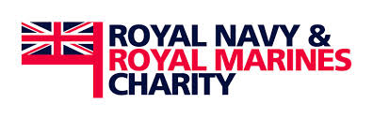
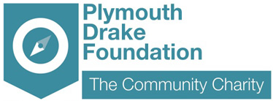

GRANT APPLICATION

Plymouth Drake Foundation Grants form
RNRMC Grant 2014

The Criteria

The Object of this Fund is “the relief of beneficiaries and their dependents who are in need by virtue of financial hardship, sickness or the effects of old age”. This was set out by the Royal Navy and Royal Marines Charity.

Plymouth Drake Foundation has £10,000 to distribute to the voluntary & community sector in Plymouth through this fund:

- Maximum amount per applicant is £2,500.
- Closing date for applicants 15th November 2014

Your project must support the following:

- Men and Women who are serving or have served in the Navel Service or the Auxiliaries and their dependants
- Beneficiaries in Financial Hardship
- Beneficiaries in sickness
- Beneficiaries suffering the effects of old age

The grant cannot fund the following:

- Trading Ventures
- Memorials, either the provision of subsequent restoration or maintenance
- The administration, running costs or governance costs of a charity
- Retrospective applications, except for grants in aid
- Grants for amenities

The final submission date is 15th November 2014

Name of group or organisation:
Contact details:
Brief Description of the main purpose of your group / organisation: (100 words)
What is the project that you want to fund: (200 words)
Details of how you would spend the grant: (200 words)

Primary Beneficiaries (eg young people) | Number of beneficiaries:
Issues the project is addressing: (eg sickness) | Total Amount Requested:
 | £
Your Annual Income: | Total Amount in your reserves:
£ | £

Cost Breakdown
Item | Description | Cost
Example: Gardening Tools | X4 Spades X2 Waste Bins | £100
 |  | £
 |  | £
 |  | £
 |  | £
 |  | £
 |  | £
 |  | £
 |  | £
 |  | £
 |  | £
TOTAL Project Budget |  | £
TOTAL Grant Requested |  | £

Please return the completed by email: plymouthdrakefoundation@gmail.com

If you have any questions please contact us:
01752 764455

