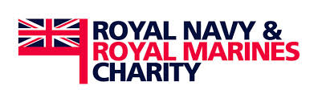
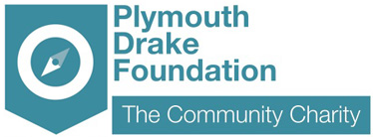

GRANT APPLICATION

Plymouth Drake Foundation Grants form
RNRMC Grant 2015

The Criteria

Plymouth Drake Foundation has £9,000 to distribute to the voluntary & community sector in Plymouth through this fund:

Maximum amount per applicant is £3,000.
Closing date for applicants is 8th January 2016.
GRANT OUTCOMES

You must demonstrate how you support at least one of the outcomes listed:
- Reducing isolation and loneliness in ex-service personal
- Increasing community participation and family cohesion for men and women who are serving or have served in the Naval Service or the Auxiliaries and their dependants
- Increase the confidence of serving or ex-serving personal to tackle their mental health problems

Your project must support the following:
- Men and Women who are serving or have served in the Naval Service or the Auxiliaries and their dependants
- Beneficiaries in Financial Hardship
- Beneficiaries in sickness
- Beneficiaries suffering the effects of old age

The grant cannot fund the following:
- Trading Ventures
- Memorials, either the provision of subsequent restoration or maintenance
- The administration, running costs or governance costs of a charity
- Retrospective applications, except for grants in aid
- Grants for amenities

The final submission date is Friday 8th January 2016

Grants will be awarded by Friday 19th February 2016 (subject to change)

The Application Form

Name of your organisation |  | Legal Structure, i.e. charity, CIC, constituted group etc
Contact Name | Address | Phone & email | Website
Brief Description of your organisation, who you are and what you do? (200 words max)
What is the project that you want to fund: (max 200 words)
When do you want the project to start? (please refer to page 1 for grant timescales)
Details of how you would spend the grant: (max 200 words)
What is the Need for your project? (max 200 words)
Please state how your project will meet at least one outcome (as stated on page 1)
(max 200 words)

Primary Beneficiaries (eg young people) | Number of beneficiaries supported:
Issues the project is addressing: (eg sickness) | Total Amount Requested:
 | £
Your Annual Income: | Total Amount in your reserves:
£ | £

Cost Breakdown
Item | Description | Cost
Example: Gardening Tools | X4 Spades X2 Waste Bins | £100
 |  | £
 |  | £
 |  | £
 |  | £
 |  | £
 |  | £
 |  | £
 |  | £
 |  | £
 |  | £
TOTAL Project Budget |  | £
TOTAL Grant Requested |  | £

Please return the completed by email: grants@plymouthdrakefoundation.co.uk
If you have any questions please contact us on 01752 764455

