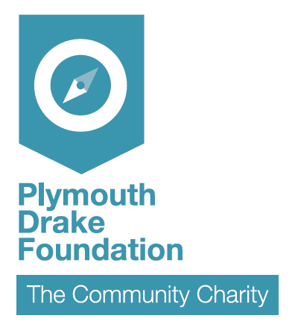
Application criteria for the funds:
- The applicant must be a Plymouth based voluntary sector organisation
- Turnover must be less than £100,000 per annum
- Applications are up to £100 per organisation
- The bursary can be used for training of Trustees / Directors, staff or volunteers
- There is no requirement for match funding although the monies can be used to partially fund more expensive courses
- The courses do not need to be accredited

Organisation making the request – please include contact details:

What training is being requested, cost, provider and proposed training date?

What are the benefits for your organisation?

Individual authorising this training on behalf of your organisation

Complete all boxes before returning this form to: Plymouth Drake Foundation, Tamar Science Park, Derriford, Plymouth, PL6 8BX or by email to plymouthdrakefoundation@gmail.com
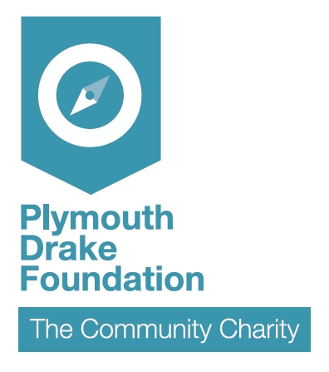
Feedback from applicants on the benefits of the training may be sought at a later date.

